**Reverence for Life**

*strengthening the practice of interbeing as a base for peaceful actions in our daily lives*

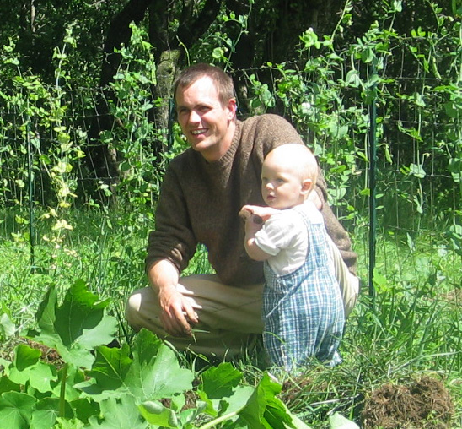

A Day of Mindfulness

in the tradition of Thich Nhat Hanh

Sponsored by Community of Mindful Living UUFR

Dharma Teacher Michael Ciborski

Saturday, October 10

8:30 am – 4:00 pm

Clara Barton Room

Unitarian Universalist Fellowship of Raleigh

3313 Wade Avenue, Raleigh, North Carolina



In the midst of our daily lives we are often pushed and pulled and occasionally even dragged about by strong emotions, stress, and difficult relationships with work and family. In these moments, the practice of reverence for life and interbeing are extraordinarily helpful steps to establish peace and clarity.  They allow us to understand more deeply what is actually going on within and around us, and act from a place of stability and freedom.  In this way we can develop a new, positive relationship to ourselves and others and transform the bitterness of suffering into a rich soil of possibilities that include ease, compassion for ourselves and others, reconciliation, and joy.

Michael Ciborski’s relaxed and light-hearted presence conveys joy and peace to all who have the opportunity to study with him.

His knowledge and practice grew from the rich soil of Plum Village, France, where he spent nearly ten years, both as a lay practitioner and as a monastic. Michael lived and worked intimately with Thich Nhat Hanh and the monastic community to organize, support, and offer meditation retreats around the world. Thich Nhat Hanh named him a Dharma Teacher in 2001. Michael returned to lay life in 2003.

He is married to Fern Dorresteyn, also a Dharma Teacher in Thich Nhat Hanh’s tradition. They have three children and live in New Hampshire, where they are building a mindfulness practice community for sustainable living called MorningSun.

For more information, see:

[truemiddleway.org](http://truemiddleway.org/)

WHAT TO BRING:

* Sitting cushion or meditation bench if you wish; chairs will be available
* Mat/blanket for relaxation
* Slippers or socks, if desired; the meditation room is shoe free.
* Mug or cup for water and/or tea

WHAT TO WEAR:

* Comfortable, loose fitting clothing; no shorts or tank tops, please!
* Umbrella, if necessary, for outdoor walking meditation

COST:

$35.00 includes vegetarian lunch

TO REGISTER:

Visit our web site at

[raleighmindfulness.org](http://raleighmindfulness.org/)

If you have problems registering, please contact Gail O'Brien: [ncgailobrien@gmail.com](mailto:ncgailobrien@gmail.com)