**A Beautiful Community, A Beautiful Life**

*strengthening the practice of interbeing as a base for peaceful actions in our daily lives*



A Retreat and A Day of Mindfulness

in the tradition of Thich Nhat Hanh

Sponsored by Community of Mindful Living UUFR

Dharma Teacher Michael Ciborski

Retreat: Friday, 9/23-Sunday, 9/25

Day of Mindfulness: Saturday, 9/24

Avila Retreat Center

Durham, NC

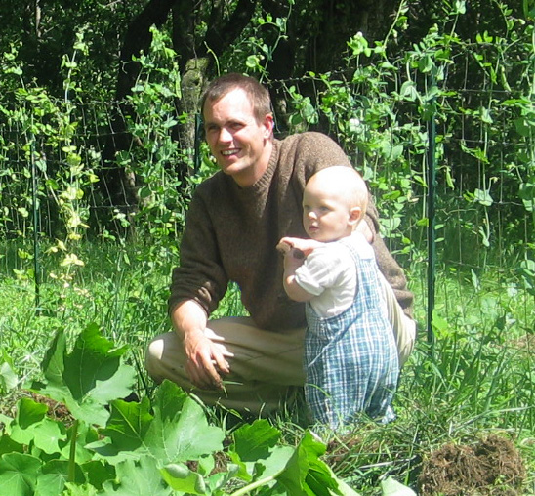

In this retreat, with mindfulness practice as a base, in sitting, walking, eating, singing, discussions and listening to teachings, we will develop our capacity to embrace and transform our suffering, and also our ability to offer understanding and joy to ourselves, our loved ones and our community.  We will explore the balance of self-care and other-care.

Michael Ciborski’s relaxed and light-hearted presence conveys joy and peace to all who have the opportunity to study with him.

His knowledge and practice grew from the rich soil of Plum Village, France, where he spent nearly ten years, both as a lay practitioner and as a monastic. Michael lived and worked intimately with Thich Nhat Hanh and the monastic community to organize, support, and offer meditation retreats around the world. Thich Nhat Hanh named him a Dharma Teacher in 2001. Michael returned to lay life in 2003.

He is married to Fern Dorresteyn, also a Dharma Teacher in Thich Nhat Hanh’s tradition. They have three children and live in New Hampshire, where they are building a mindfulness practice community for sustainable living called MorningSun.

WHAT TO WEAR:

* Comfortable, loose fitting clothing; no shorts or tank tops, please!
* Umbrella, if necessary, for outdoor walking meditation

COST:

$165-185 for Retreat

$45 for Day of Mindfulness

TO REGISTER:

Visit our web site at

[http://raleighmindfulness.org](http://raleighmindfulness.org/)

If you have problems registering, please contact Gail O'Brien: [ncgailobrien@gmail.com](mailto:ncgailobrien@gmail.com)